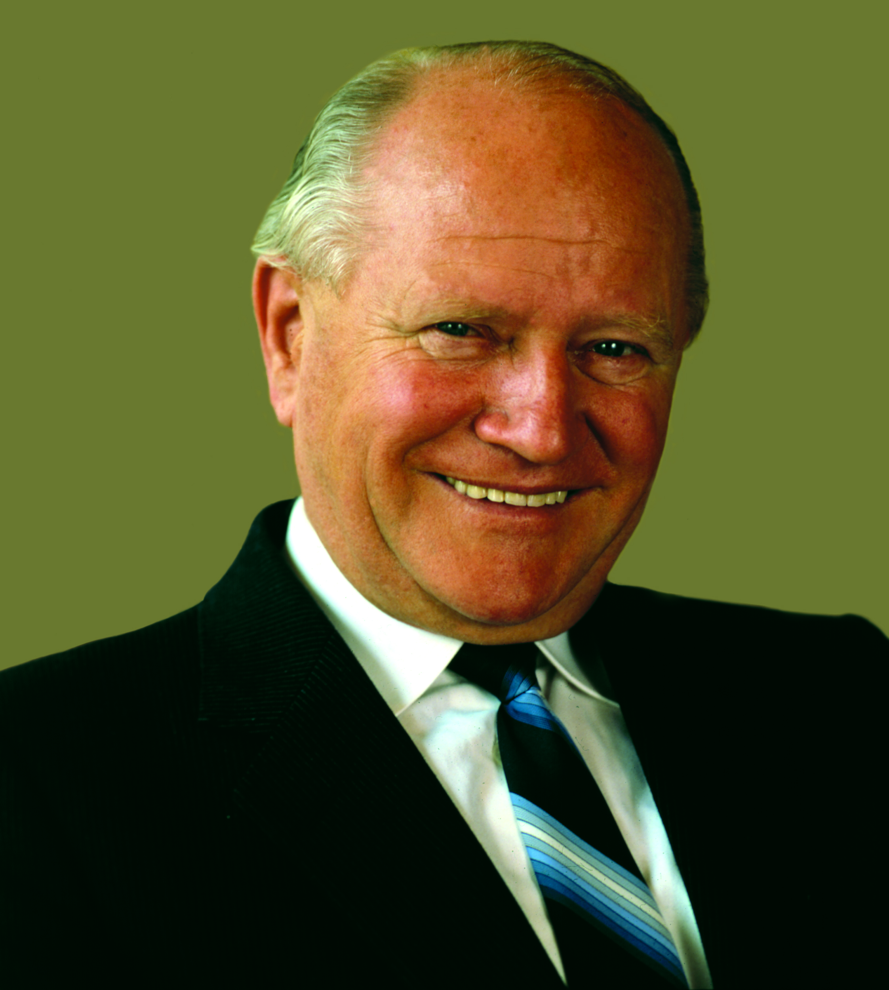
Oskar Lapp (1921-1987) carved himself a place in German business history You can find the image in printable quality here.

Oskar Lapp at 100 – A pioneer for the future

“My husband was brave and God gave him a lot of talents”, says Ursula Ida Lapp (90) of her husband, who died on 25 April 1987.

Oscar Lapp was born on 20 March 1921 in Benshausen in the eastern part of Germany, one of four children from a craftsman’s family. From an early age, he showed an impressive talent for technical things and an inventive spirit. After being a prisoner of war and subsequent fleeing across the “green border” to escape the former Communist GDR, in the mid-1950s he began a new life with his family in West Germany.

Starting again was tough, as he had left behind everything he owned when he fled to the west. Oskar Lapp initially worked for Harting, where he was responsible for the Southern Germany region. And his innovative ideas also started to attract attention. For example, he developed the first rectangular connector for industry for the company. Thanks to his many meetings with customers, Oskar Lapp knew exactly what users needed. The electrical connection in particular was very laborious: The cores were all black or grey and the electrical engineers had difficulty assigning the cores to the correct ends when connecting. This required a complex process, known as continuity testing. Oskar LAPP invented a flexible cable made of coloured cores. ÖLFLEX® was born. It was the first industrially manufactured power and control cable - an invention that revolutionised connection technology. It was innovative in another way too: Oskar Lapp was the first entrepreneur ever to give an industrial product a brand name. Today, the ÖLFLEX® brand still stands for exceptionally oil-resistant and flexible control cables across the world.

In 1959, the Lapps founded their company with the assistance of a 50,000 Mark bank loan. As Oskar Lapp was still employed at Harting, Ursula Ida Lapp was entered in the commercial register as the company’s founder. The company name was created at the kitchen table: U.I. LAPP KG - U.I. Stands for Ursula Ida. As with so many start-ups today, the Lapps’ business began from the garage of their house in Stuttgart-Vaihingen. Oskar Lapp took care of sales while Ursula Ida Lapp looked after the accounts, orders and logistics from home, while taking care of their young children.

With ÖLFLEX®, Oskar Lapp set quality standards that are still applicable all over the world in cable production today. He was even offering ready made cable harnesses with up to 130 coloured cores. Demand was huge. LAPP was also one of the first suppliers to offer and cut the cable harness length to customer requirements. ÖLFLEX® was the right product at the right time and sales grew rapidly. Later, UNITRONIC® data transmission systems, HITRONIC® fibre optic cables, SKINTOP® screwed cable glands, SILVYN® cable protection and guiding systems, EPIC® industrial connectors, ETHERLINE® data transmission systems for ETHERNET technology and FLEXIMARK® marking systems were added.

In 1963, the company opened the first factory of its own to produce ÖLFLEX® cables. In 1965, the company moved from the family home in Stuttgart-Vaihingen to Schulze-Delitzsch-Straße, where it is still based today. Because of his painful experiences as a Soviet prisoner of war, Oskar Lapp was always committed to establishing international business relationships and friendships in the west. He found his first sales partners in Switzerland and Israel back in 1960. Oskar Lapp founded the first international subsidiary in the USA in 1976, which he no doubt saw as the exact counterpoint to the Soviets during the Cold War.

At the same time, he positioned his company as a one-stop shop in connection technology and this principle remains a successful formula to this day. “Our father led our company to success with hard work and ambition and with a clear view of what is really important. He exhibited persistence, entrepreneurial spirit and innovation and these are still part of LAPP’s DNA today”, says Siegbert Lapp, Chairman of the Supervisory Board at LAPP Holding AG.

When Oskar Lapp died in 1987, his wife Ursula Ida Lapp and his two sons Siegbert and Andreas Lapp took over the running of the company. At the end of the 90s Oskar Lapp’s widow handed over day-to-day operations to her sons. Under their aegis, there has been greater internationalisation and a focus on solutions. Today, LAPP is one of the leading suppliers of integrated solutions and branded products in the field of cable and connection technology. LAPP currently employs approximately 4,575 people across the world, has 20 production sites and around 43 sales companies. It also works in cooperation with around 100 international representatives.

Andreas Lapp is currently Chairman of the Board of the global holding company LAPP Holding AG, while his brother Siegbert E. Lapp is Chairman of the Supervisory Board. Ursula Ida Lapp is Honorary Chairwoman of the Supervisory Board and is present at important events in the company. Two grandchildren have also already taken on responsibility within the company. Matthias Lapp assumed the position of CEO for Europe, including South America, Africa and the Middle East in 2017. Alexander LAPP is responsible for digitisation and e-business at the holding company.

In memory of Oskar Lapp, the founding family set up the Oskar Lapp Foundation in 1992. This provides young scientists with incentives to effectively engage them in cardiovascular research. The Oskar Lapp Research Prize, worth 12,000 Euro, is presented annually, while the Oskar Lapp Grant, which provides up to 20,000 Euro for equipment, is awarded every two years.

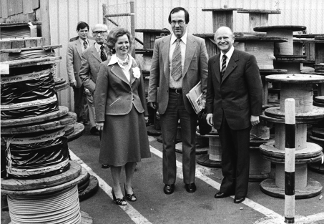

Ursula Ida and Oskar Lapp on a tour of the company with former Mayor of Stuttgart Manfred Rommel
You can find the image in printable quality here.

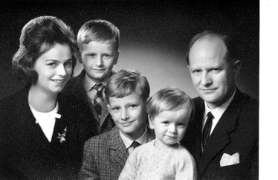
Ursula Ida and Oskar Lapp with their children Siegbert, Andreas and Volker
You can find the image in printable quality here.

